## USer-Provider Association

The HIE’s Provider Directory contains information about care providers and other entities from the NPI Registry and from provider information added locally (see “Provider Directory” for more details).

The **Provider Association** feature in the *User Security* screen allows this information to be connected to a user account.

While viewing a user’s account information in the *User Security* screen, click the **Provider Association** bar to expand the provider association window. Click on **Associate** to search for a provider.

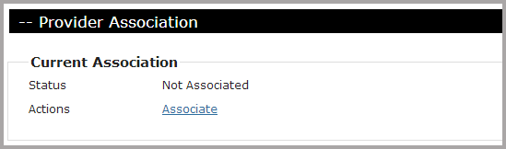

*First Name* and *Last Name* will be auto-populated from the basic user account information entered previously. Enter the provider’s NPI, if known, to narrow the search.

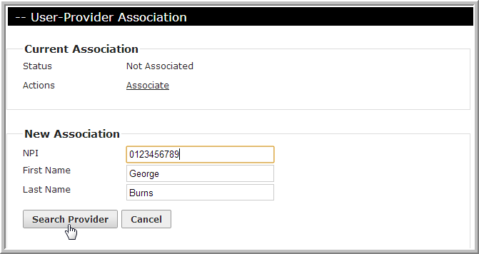

Results of the search will appear in the *New Association* section. Click **Associate** beside the correct result.

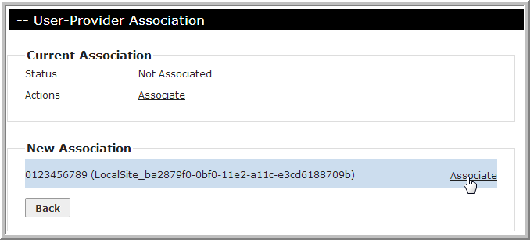

The user account is now associated with the entry in the Provider Directory. Click **Propagate User Information** to auto-populate data from the Provider Directory with corresponding fields in the user account.

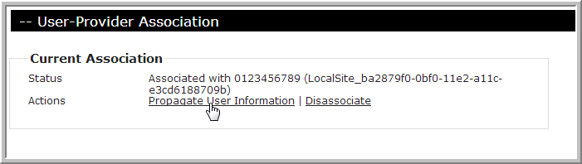

If the association was made in error or later needs to be removed, click **Disassociate**.

Note: any unwanted information previously propagated in the user account must be manually removed.